Stuff to Know - LateX

**Software**

* Download MikTex
* For windows (you should get an exe called TeXWorks)
* Open TeXWorks and open any .tex file
* In format toolbar you can change the syntax colouring to LateX

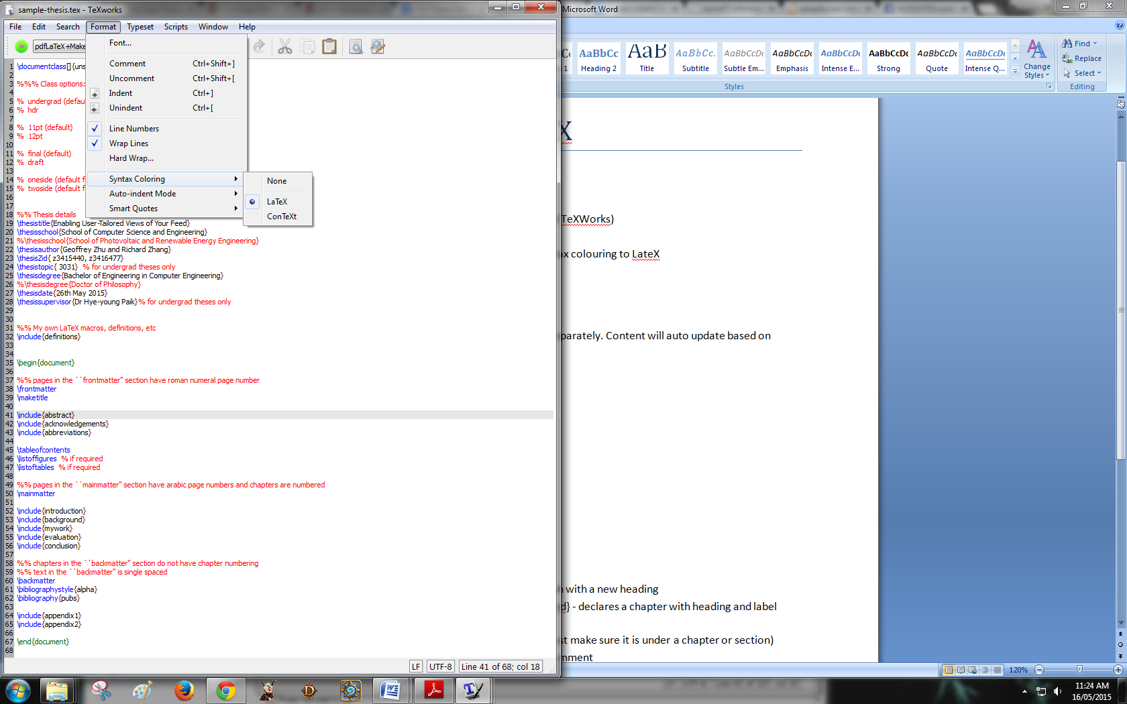

**Format**

Each part has its own file so it can be worked on separately. Content will auto update based on sections so we don't need to modify it

* abstract
* acknowledgements
* abbreviations (may not need)
* listoffigures
* listoftables
* intro
* background
* mywork
* evaluation
* conclusion

**Commands**

* \section{<Insert Title>} - used to paragraph with a new heading
* \chapter{Background}\label{ch:background} - declares a chapter with heading and label
* not sure what label is for
* No commands are needed to write text (just make sure it is under a chapter or section)
* comments can be written with % insert comment
* To include images:
* Place image in images folder in report
* \includegraphics{dog.jpg} replace dog.jpg with filename
* There is an example in sample-thesis.tex (ctrl+f Image Example)
* To do dot points
* \begin{itemize}
* \item The first item
* \item The second item
* \item The third etc \ldots
* \end{itemize}